**Project Charter**

**BlackjackPark**

**18 May 2023**

**Senlin Sun and Abhinav Mukkala**

# PROJECT STATEMENT

Our friend Parker is looking for a small program to play blackjack with a UI and the ability to continue playing with a fake “balance” to raise the stakes in the game. 2D array will be used to represent a card deck with values and suit. Queues will be used to simulate the player and dealer’s cards. Recursion will be used when deciding when the dealer should stop drawing cards.

# CONCISE PROJECT OVERVIEW

We, the developers of BlackjackPark, are trying to create a program that simulates blackjack with a single deck. We are constrained by our time limit of less than a month, as well as other things going on in school, which may distract from work efficiency.

# SCOPE STATEMENT

Have at least 3 usable functionalities, including the ability to calculate card values, randomized draw from a set deck of cards, by June 5th with a UI capability. Win Loss conditions will affect the balance. Having this capability will meet the expectations of our stakeholder and client Parker.

# STAKEHOLDERS

Our friend Parker would like to have a nice application that can play blackjack. A simple windows program UI would be nice. He would like to see success in this project. Senlin and Abhinav are also stakeholders in this as they would like to see success in the project and possible use.

# TIMELINE

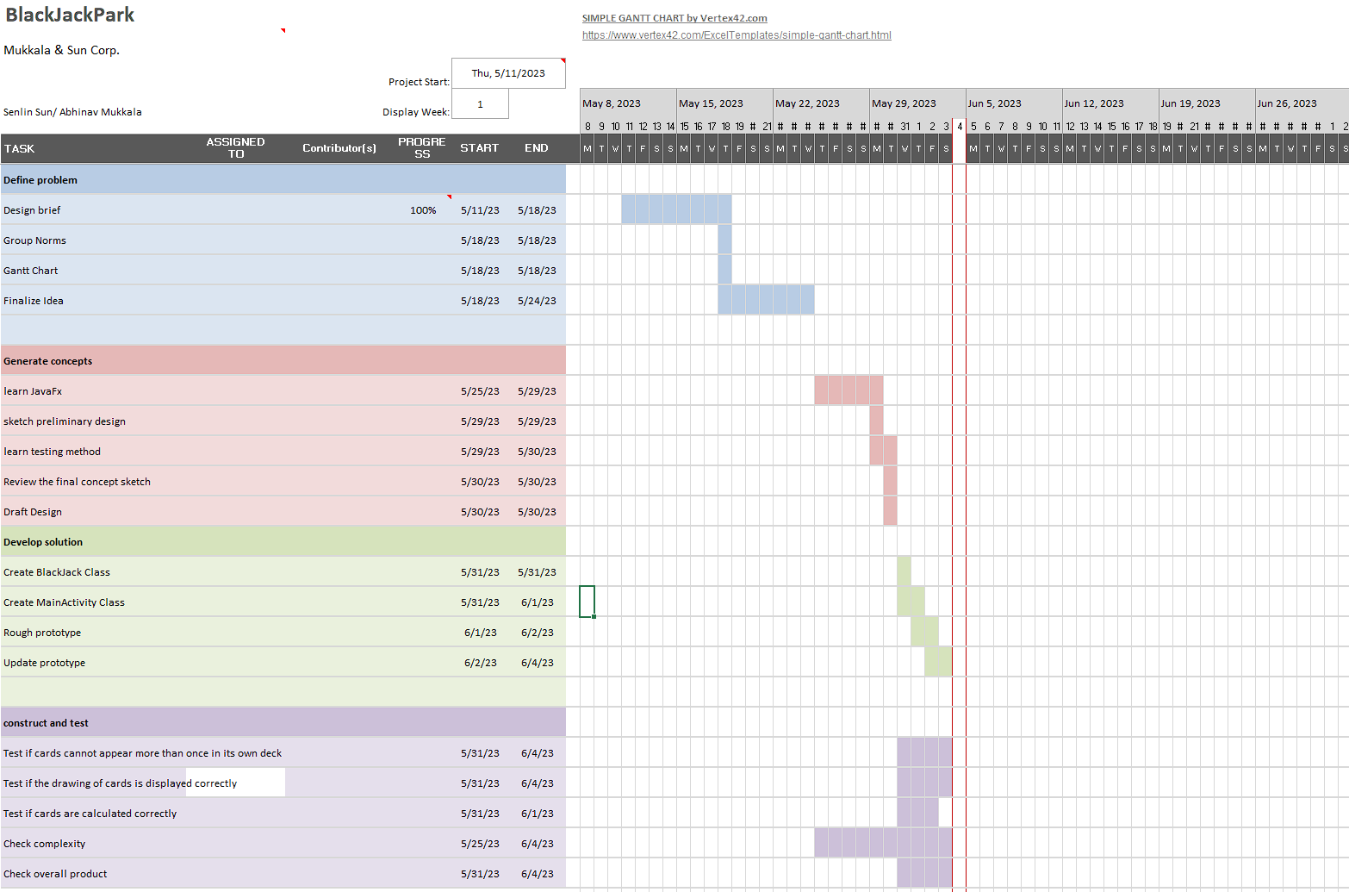

# BUDGET ESTIMATE(S)

* Time available until the due date (June 5)
* Abhinav and Senlin’s time
* Classroom computers, school laptops and personal laptops
* IntelliJ IDE (free)
* Power, time and effort for testing

# RISKS AND CONTINGENCY PLANS

List known and potential risks by estimated probability, with mitigation plans

* Huge workload and studying during finals week and upcoming to finals week distracts project members from finishing the task and following the timelines. (highly probable because project members are procrastinators)
  + Look ahead in the calendar and allocate specific chunks of time each day (or some routine) in order to avoid too much work on one day
* Random large projects in other classes (somewhat probable since a lot of teachers love giving out projects in the end of year and IB classes have to finish up requirements and stuff)
  + Look ahead in the calendar and try to balance projects by allocating time to each on a routine. (not randomly or spontaneously)
* Learning JavaFX does not work (unprobable I think)
  + Switch to another java UI OR switch to console game

<https://github.com/skyline-high-school/year-end-csproject-abhinav-and-senlin/tree/master>